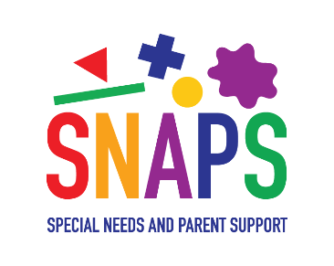

In order to say safe,
We have to stay at home,
So let’s record my hand and footprint,
To look back on when I’m grown!

