BUSINESS PLAN
OCTOBER 2017 - MARCH 2019
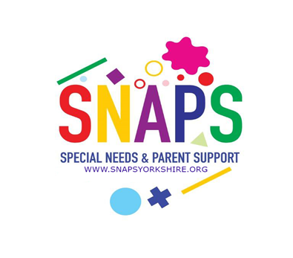

SPECIAL NEEDS AND PARENT SUPPORT YORKSHIRE CIO
INTRODUCTION

This document is the business plan for our charity, Special Needs and Parent Support, or SNAPS, for the 18 month period from October 2017 to March 2019. The pace of change over the last couple of years has led the Board of Trustees to work to single year Business Plans. However, we have reached the point in our development where we need to take a longer term view, and so have decided to put in place a Plan covering the 18 month period from October 2017, subsuming the former Plan which covered the period from April 2017 – March 2018. There is still a high volume of change but we need a longer time frame to better express and plan our activities.

The new draft builds on the previous Business Plans, which ran from October 2014 to September 2017, and provided the ‘road map’ for the many changes and improvements during that period. We have effectively spent much of that period building, rebuilding and implementing an improved infrastructure for the organisation to enable SNAPS to be a soundly based, developing and sustainable organisation. A great deal of credit for helping to bring about the changes required lies with the Board of Trustees who have developed the strategy and the staff team who have managed the delivery so effectively. In the Business Plan where dates are mentioned, ‘financial 2017’ means the period April 2017 – March 2018, ‘financial 2018 means the period April 2018 – March 2019, and therefore Q3 financial 2017 would be the third quarter, October – December 2017, Q4 would be January – March 2018, and so on.

A BRIEF HISTORY

SNAPS was first established in Leeds in March 2004 as a parent led organisation, and continues to involve parents at all levels. The parents identified an unmet demand for hydrotherapy, swimming and physical activity experiences, all of which can have such a positive impact on both the children and their families – these experiences can be literally life changing, and help the whole family relax and enjoy time together. From that modest beginning, we have continued to grow, and deliver a consistent support service to a wider and wider group of families and their children. Since Autumn 2014, SNAPS has grown to provide, in Autumn 2017, six times as many therapeutic activity slots. The aim of the Trustees was to design and operate a business model which could be replicated elsewhere, and then expand to other sites in the Leeds area, thereby providing further support to more families across the region. At our site in North Leeds (Penny Field School) we have been operating at the maximum number of Saturdays available per term since 2016, and from January 2018 we will be operating either at, or close to the maximum number at the South Leeds site (Broomfield School).

VISION

Our vision for SNAPS continues to be to build an inspirational place connecting families and children with a wide range of challenges and opportunities. We aim to promote health and well-being for all by providing opportunities for people to meet, learn, play, and build relationships. We are an inclusive organisation, involving the whole family, including siblings with no additional needs. SNAPS welcomes all, including those who are socially and economically disadvantaged, and is an open access, non-referral organisation.

AIMS

The aims of SNAPS, according to our Constitution, are:
- To provide leisure services for children with additional or special needs, and their siblings;
- To provide parents and carers with the opportunity to share information, ideas and experiences with other families of children with special needs;
- To raise funds to help provide services and equipment for those children; and
- To be a fully inclusive group.

GOALS

SNAPS has three equally important primary goals:

- To provide Hydrotherapy and Rebound therapy sessions for children with additional needs, along with swimming lessons for those able to participate, including siblings where appropriate;
- To provide music therapy, music, boccia, and other fun physical activities, arts and crafts, and soft toy play;
- To provide an opportunity for social interaction, mutual support and friendship for both children and their families, and to do so from several sites across Leeds.

To help achieve these goals, SNAPS operates with the heart of a charity and the mind-set of a business. We attain our charitable goals by designing and delivering a tightly structured plan.

THE DETAILED BUSINESS PLAN

The business strategy for SNAPS comprises a series of steps, all of which are to be delivered or commenced over the next 18 months. To support the achievement of the strategy, we have produced separate but linked plans for 7 primary areas of focus:

- Governance;
- Operations and Information Technology;
- People and Organisation;
- Finance, Reserves, Assets, Cost Recovery and Revenue Generation;
- Strategic Planning and Market Awareness;
- External Relationships, Communications and Social Media; and
- Risk Management and Legal Issues.

